 | Sunday  MARCH  5th  Communion | Sunday  MARCH  12th  Ministry Meetings | Sunday  MARCH  19th | Sunday  MARCH  26th
 | 2nd Sun Lent | 3rd Sun Lent | 4th Sun Lent | 5th Sun Lent
Lay Reader | Calib Chi  Gen 12:1-4 | Ernest Mfobujong  Exodus 17:1-7 | Pam Carter  1 Sam 16:1-13 | Paul Beh  Ezekiel 37:1-14
Lay Reader | Evan Akum  Psalm 121 | Jacqueline Tekwe  Psalm 95 | Thelma Abunaw  Psalm 23 | Prince Akum  Psalm 130
Lay Reader | Precious Abeh  Rom 4:1-5, 4:13-17 | Bernard Mbah  Rom 5:1-11 | Tyler Abunaw  Ephesians 5:8-14 | Amban Anjeh  Romans 8:6-11
Focal Scripture | John 3:1-17 | John 4:5-30 | John 9:1-41 | John 11:1-45
Series:  Sermon Title: | Found In God | The Complexity of Thirst in the Wilderness | Eyes to See As The Shepherd Sees | The Breath of  New Life
Greeters | Asher Tekwe | Tina Pawlik | Paoula Abunaw | Benita Moti
Greeters | Ava Johnson | Kevin Matthis | Ophilia Samba | Mitzi Ecker
Greeters | Sammy Kembumbala | Cassandra Azue | Chris Ndzo | Janelle Tanwani
Greeters | Thelma Abunaw | Bryanna Moti | Anye Mfobujong | Miquel Tangwan
Ushers | Prince Akum | Martin Aluna | Brinley Tebit | Joycy Akum
Ushers | Jayden Tanwani | Christy Aluna | Mbangza Ade | Vivian Chawchang
Ushers | Pryde Akum | Shadrack Moti | Calib Chi | Jayden Tanwani
Ushers | Eni Kuchambi | Brittney Moti | Nelly Enone | Pryde Akum
Ushers | Ambang Kuchambi | Dickson Esakenong | Benita Moti | Asher Tekwe
Children’s Sermon / Children’s Church | Children’s Sermon Pastor Donna
Special Music | Youth | CMF | CWF
Assisting Elder | Beatrice Muma | Tanwani Akum | Akwa Angwafo | Nelly Enone
Assisting Deacon | Walters Musi | Ophilia Samba | Jacquelin Tekwe | Cassandra Azue
Counter | Walters Musi / Cassandra Azue | Denis Chawchang | Jacquelin Tekwe | Cassandra Azue
Counter | Oliver Fonteh | Pauline Tanwani | Odilia Jator/  Stephen Abunaw | Odilia Jator/  Bernard Abeh
Counter | Ophilia Samba | Pam Carter | Walters Musi/  Chris Ndzo | Paul Beh
Counter | Jacquelin Tekwe | Emmanuel Akum | Vivian Mbah | Eric Chi
Groups Cleaning | Youth | CMF | CWF | Congregational Volunteers
Those Who Serve
MARCH 2023

Deacon of the Month: Vivian Mbah

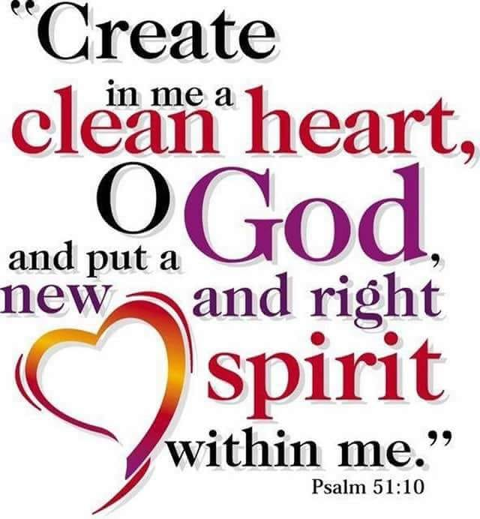

 | Sunday  MARCH  5th  Communion | Sunday  MARCH  12th | Sunday  MARCH  19th | Sunday  MARCH  26th
Prelude | Music Ministry  _______________ | Music Ministry  _______________ | Music Ministry  _______________ | Music Ministry  _______________
Praise | Music Ministry | Music Ministry | Music Ministry | Music Ministry
HYMN 1 | Lift Him Up | 428 In Christ There is No East or West | #688 Savior Like A Shepherd Lead Us | #390 Spirit of God Descend Upon My Heart
Special Music | Youth Choir | CMF | CWF | Music Ministry
Offertory | Youth Choir | CMF | CWF | Music Ministry
Sermonic | n/a | #86 Jesus Name Above All Names | #633 Open Our Eyes, Lord | #393 “Breath on Me, Breath of God”
HYMN 2 | Let Us Break Bread Together | #716 “Jehovah Jireh” | #563 Open My Eyes  That I May See | Call & Response*  “We Are Marching In The Light of God”
Other

